ASSIGNMENT-03

|  |  |
| --- | --- |
| Student name | Nisha R |
| Register number | 513319104021 |
| Marks | 2 marks |

# Qn-4: Design a chatbot using IBM Watson assistant for hospital. Ex: User comes with query to know the branches for that hospital in your city. Submit the web URL of that chat bot as a assignment.

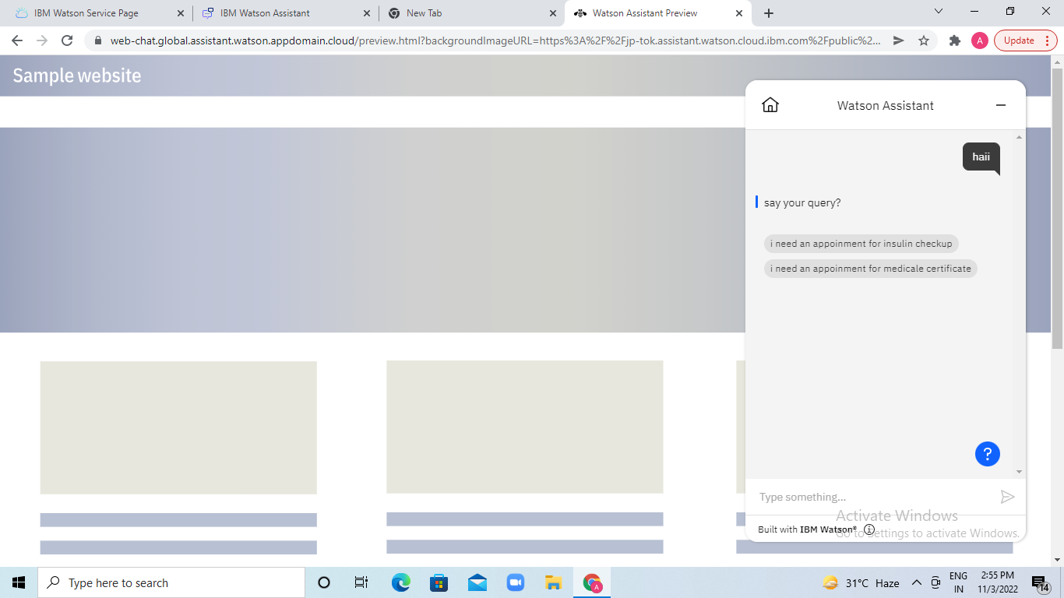

**OUTPUT:**

# https://web-chat.global.assistant.watson.appdomain.cloud/preview.html?backgroundImageURL=https%3A%2F%2Fjp-tok.assistant.watson.cloud.ibm.com%2Fpublic%2Fimages%2Fupx-bfcf1c3c-e314-46cc-b6c0-9c0066fc3b42%3A%3A2e231e89-21b3-4ad3-8585-b7eebcde8cce&integrationID=ca0ec412-55bd-4031-83f6-ae531f8a3d85&region=jp-tok&serviceInstanceID=bfcf1c3c-e314-46cc-b6c0-9c0066fc3b42

# Qn-5: Create Watson assistant service with 10 steps and use 3 conditions in it. Load that script in HTML page.

**OUTPUT:**

<!DOCTYPE html>

<html>

<head>

<title>IBM Watson Assistant</title>

</head>

<body>

<a href="https://web-chat.global.assistant.watson.appdomain.cloud/preview.html?backgroundImageURL=https%3A%2F%2Fjp-tok.assistant.watson.cloud.ibm.com%2Fpublic%2Fimages%2Fupx-bfcf1c3c-e314-46cc-b6c0-9c0066fc3b42%3A%3A2e231e89-21b3-4ad3-8585-b7eebcde8cce&integrationID=ca0ec412-55bd-4031-83f6-ae531f8a3d85&region=jp-tok&serviceInstanceID=bfcf1c3c-e314-46cc-b6c0-9c0066fc3b42">click to see my chatbot</a>

</body>

</html>